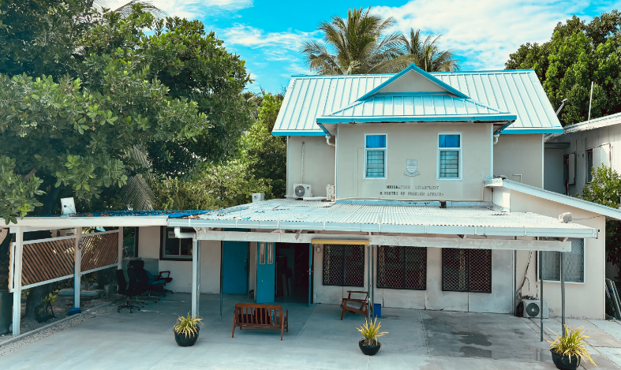
About Us
Role and Function

The Asia Pacific Division leads and strengthens Kiribati’s diplomatic relations in the Asia-Pacific region, advancing national interests through strategic partnerships, foreign policy development, and economic advocacy, guided by its mission to create opportunities and build strong networks.

Thank You

Contact Us

- Email: apd-staff@mfa.gov.ki
- Phone Number: 75021342/75021
- Extension Number: 213

Asia Pacific Division

Scan to read more


Ministry of Foreign Affairs & Immigration

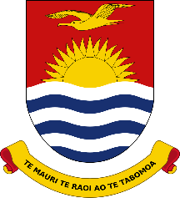

Role and Function

Meet the Team

i
www.mfa.gov.ki

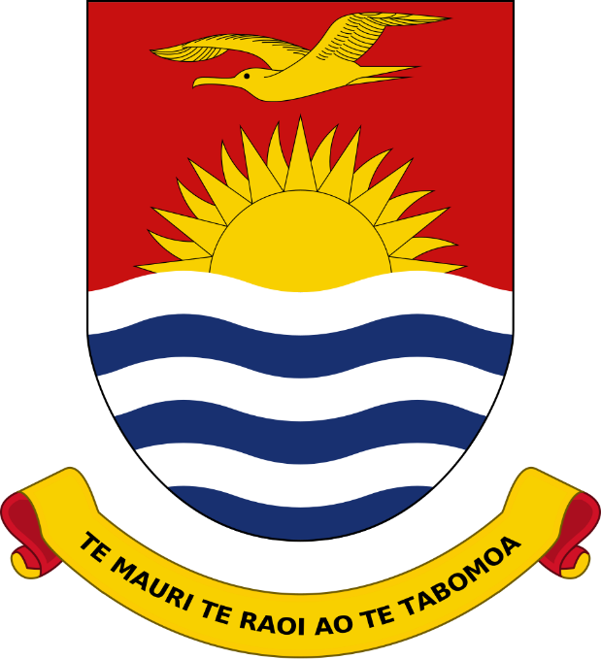

Asia-Pacific Diplomatic Partners

PACIFIC REGION
Fiji, New Zealand, Samoa, Australia, Solomon Islands, Tuvalu, Papua New Guinea, Vanuatu, Nauru, Tonga, Federated States of Micronesia, Marshall Islands, Palau, and Cook Islands
ASIA REGION
Japan, Republic of Korea, People’s Republic of China, Malaysia, Bangladesh, India, Maldives, Singapore,Philippines, Thailand, Indonesia, Mongolia, Vietnam, Brunei Darussalam and Pakistan

- Assist in developing the Strategic Management of the Division
- Develops and maintains foreign policy objectives relating to countries and organization within the Asia Pacific Region;
- Monitors and advocate Government’s Foreign Economic Policy
- Prepare briefing, policy advisory papers and draft statements on issues related to divisional and represent the Ministry at national regional or international meetings.

ORGANISATIONS
Pacific Islands Forum (PIF), South Pacific Community (SPC), Asian Development Bank (ADB), South Pacific Regional Environment Program (SPREP), University of the South Pacific (USP), Party to the Nauru Agreement (PNA), South Pacific Tourism Organisation (SPTO), Pacific Aviation Safety Office (PASO), Pacific Power Assosication (PPA)

Director: Mr Teata Terubea
Deputy Director: Ms Turia Tekirua
Desk Officers: Ms Oema Riteri, Ms Iunia Teruta, Mr Gideon Nabuti & Ms Rubeteiti Kotete

