Multilateral Affairs Division
Ministry of Foreign Affairs and Immigration
Bairiki, Tarawa
Republic of Kiribati

Phone: +686 75021342
+ 686 75021343
Website: www.mfa.gov.ki/multilateral
Email:
doma2@mfa.gov.ki
doma3@mfa.gov.ki
doma4@mfa.gov.ki

CONTACT

Role and Function


Thank You

multilateral affairs division

Scan to read more

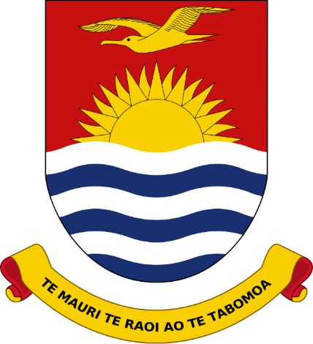

Ministry of Foreign Affairs & Immigration

DIPLOMATIC RELATIONS
KEY ROLES & FUNCTIONS
Maintain and strengthen Kiribati’s relations with countries across the European, Mediterranean, Caribbean, African, Middle Eastern, and the Americas regions.
Promote the representation of Kiribati and advocate national priorities within international organisations of which Kiribati is a member.
Coordinate Kiribati’s participation in multilateral processes, including United Nations elections, negotiations on UN resolutions, and monitoring compliance with regional and international treaties.
Facilitate the deposit of instruments of accession or ratification for multilateral treaties.
Support and facilitate Kiribati’s participation in high-level international engagements, including the United Nations General Assembly and the Commonwealth Heads of Government Meeting.
Coordinate Government engagement in multilateral development initiatives, including South-South Cooperation and access to development financing through multilateral trust funds.
The Republic of Kiribati currently maintains four (4) Diplomatic Missions overseas.
Two (2) of these Missions fall under the portfolio of the Multilateral Affairs Division (MAD), namely the Permanent Mission of the Republic of Kiribati to the United Nations in New York and the Permanent Mission of the Republic of Kiribati to United Nations in Geneva.
DIPLOMATIC MISSIONS
The Government of the Republic of Kiribati has established diplomatic relations with one hundred (100) countries to date.
Of these, seventy-one (71) countries fall under the portfolio of the Multilateral Affairs Division (MAD).
Through MAD, Kiribati also participates as a member of several international organisations, including the United Nations and its specialised agencies, the Commonwealth, the World Bank, and the Asian Development Bank, among others.
ABOUT US
The Multilateral Affairs Division (MAD) is one of the seven (7) divisions within the Ministry of Foreign Affairs and Immigration. Multilateral affairs refer to diplomatic relations and partnerships involving a group of countries—typically three or more—often conducted through multilateral institutions and intergovernmental organisations (IGOs).
In this regard, MAD primarily manages Kiribati’s engagement with multilateral institutions such as the United Nations and other intergovernmental organisations. In addition, the Division oversees bilateral relations with countries in the European, Mediterranean, Caribbean, African, Middle Eastern, and the Americas regions.
The Division comprises a total of five (5) personnel: the Director of Multilateral Affairs (DMA), the Deputy Director of Multilateral Affairs (DDMA), and three (3) Desk Officers.
The Division works in close coordination with two (2) of Kiribati’s Permanent Missions to the United Nations.
www.mfa.gov.ki

