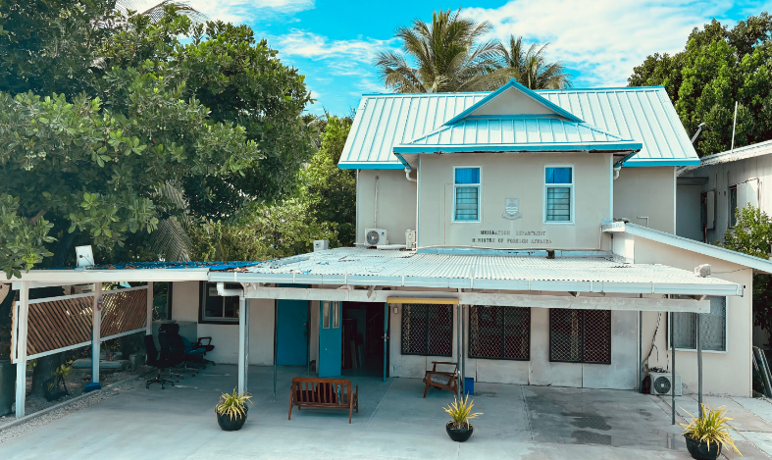
About Us
Role and Function

The Protocol Division is a specialized unit within government ministries or organizations that manages diplomatic protocols, ceremonial functions, and official engagements.

Contact Us
MFAI Office Number: 75021342

Email Address: po@mfa.gov.ki
Email Address: apo@mfa.gov.ki
Email Address: apo2@mfa.gov.ki

Protocol Division


Thank You

Scan to read more

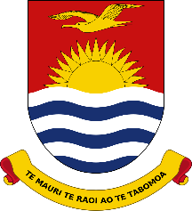

Ministry of Foreign Affairs & Immigration

i
www.mfa.gov.ki

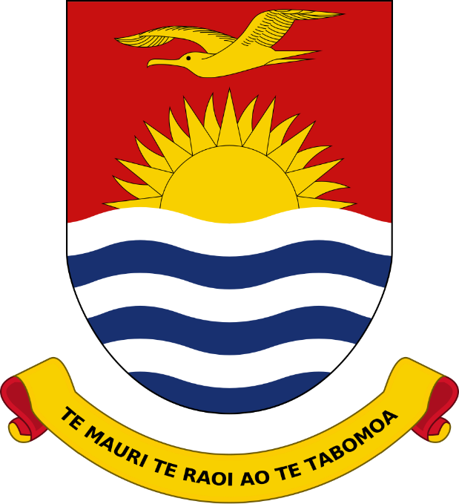
Role and Responsibilities
Services

- Diplomats Services
- Protocol training
- Communication
- Visa conveyance

- Event and Ceremony Management: Planning, Coordinating and Executing official events, ceremonies and meeting while adhering to, established protocols and etiquette.
- Advising on Protocol: Providing, guidance on, official, etiquette, cultural customs and diplomatic, practices to internal teams and leadership.
- Communication: Acting as the Central point of, contact for, logistical, arrangements.
- Visa conveyance: Visa conveyance refers to the administrative process of transferring or confirming an existing visa

(TEAM PROTOCOL)

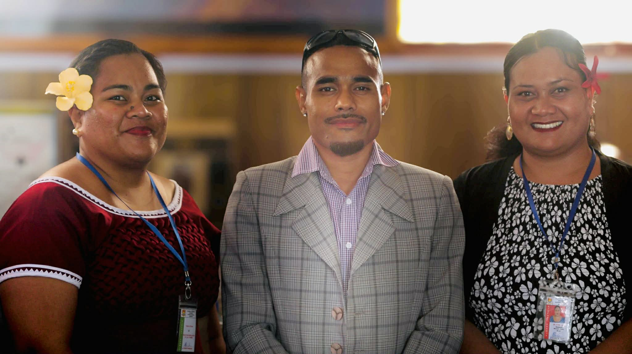
Ms. Reti Angimarau – Protocol Officer
Ms. Bwabwai Marewenibeia – Assistant Protocol Officer
Mr. Teunroko Raieta – Assistant Protocol Officer
Position & Title

