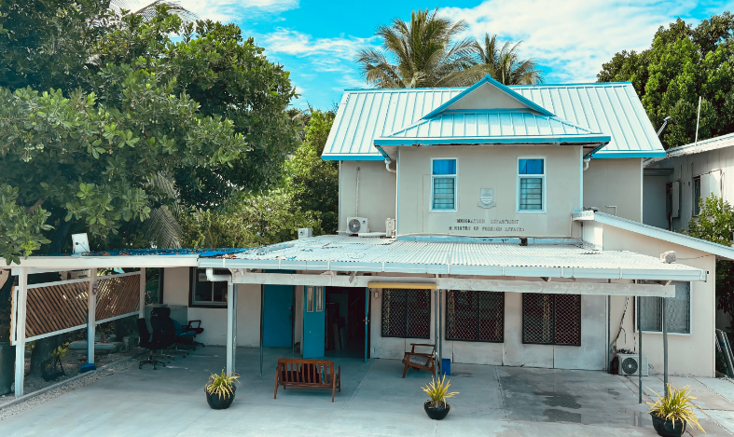
About Us
Role and Function

Dedicated to safeguarding Kiribati’s borders, the Immigration Division manages citizenship, visas, and travel documents with professionalism and integrity. Guided by laws and regulations, we ensure that all immigration processes are conducted efficiently and in full compliance with statutory requirements. Our goal is to maintain border integrity while facilitating lawful movement of people.

Contact Us
📞 Phone: +686 75021342
📧 Visa Enquiries: visaofficer@mfa.gov.ki
📧 Passport Enquiries: passportofficer1@mfa.gov.ki
🌐 Website: http://www.mfa.gov.ki
📍 Address: Bairiki, Tarawa, Kiribati

Immigration Division


Thank You

Scan to read more

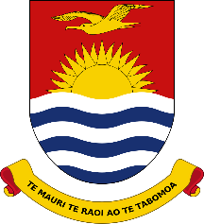

Ministry of Foreign Affairs & Immigration

www.mfa.gov.ki
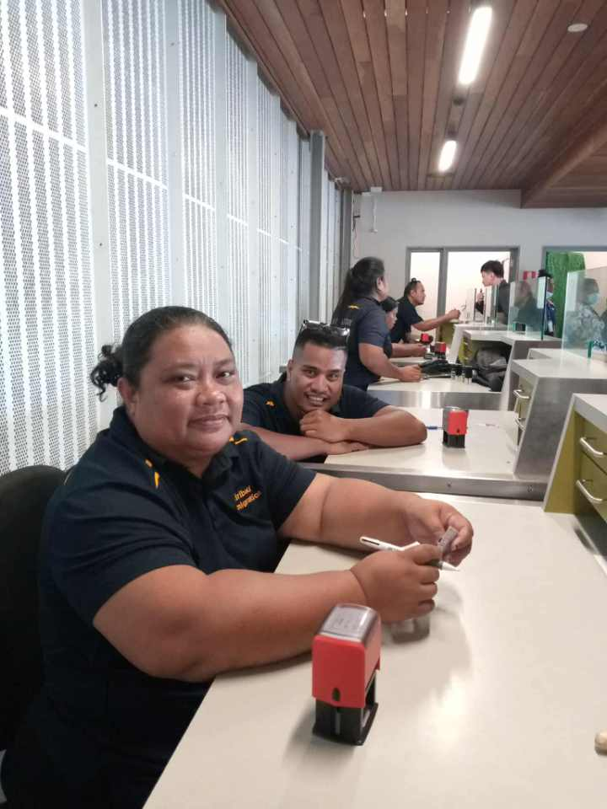
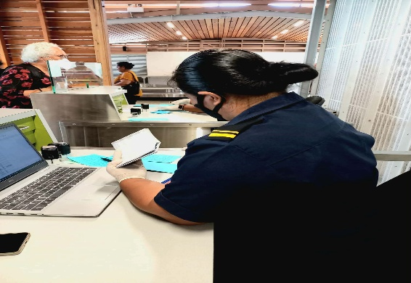
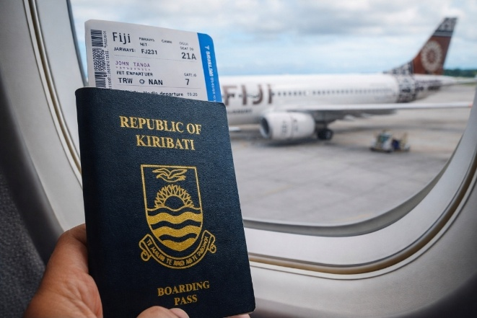
CITIZENSHIP AND PERMANENT RESIDENCE COMMISSIONS
Citizenship Commission review and make decisions on applications for obtaining, renouncing and regaining citizenship.
Permanent Residency allows a non-I-Kiribati individual who is married to an I-Kiribati citizen and has children from the marriage to apply for a permanent residency permit. Applicants must have resided in Kiribati for at least seven consecutive years, demonstrate good character, maintain a clean police record, be able to speak and understand the Kiribati language, respect Kiribati customs and traditions, and have sufficient means of support.
Kiribati Immigration’s role is the Secretariat for both Commissions, advising, recommending and submitting applications for the Commissions’ approval.

Immigration and Passport Services provide support and guidance to individuals applying for visas and travel documents. This includes advising applicants on visa and passport requirements, assisting with the completion of application forms, reviewing supporting documents, and guiding applicants through the submission and processing procedures. Our goal is to facilitate a smooth and efficient process while helping applicants meet all immigration and travel requirements.

KIRIBATI SECURITY & ENFORCEMENT COMMITTEE (KSEC)
A national Committee that has oversight of all security related issues impacting Kiribati both domestically and internationally.
Kiribati Immigration serves a vital role as the Secretariat, facilitating coordination and ensuring the effective functioning of KSEC

What are the visa categories?
- Visitor visa – for tourism, visiting families/ friends, or short-term business (3 months maximum)
- Work visa – for individuals intending to work (short term and long term)
- Student visa – for individuals intending to study in Kiribati
- Transit visa – for traveller passing through
- Permanent Residence visa – allows an individual to live indefinitely in Kiribati
For visa enquiries, please email visaofficer@mfa.gov.ki

WHAT WE DO..
📌 Safeguarding our Borders
Monitor and protect Kiribati’s borders in accordance with laws and regulations. Address and resolve cases of unauthorized or irregular entry into Kiribati in line with national laws.
📌 Visa Services
Assess and issue entry permits and visas for entry into Kiribati.
📌 Passport Services
Issue and renew passports and other official travel documents in compliance with national laws and international standards.
📌 Citizenship Administration
Process applications for Kiribati citizenship to be considered by the Citizenship Commission
📌 Advisory and Support Services
Provide guidance and information to the public on immigration processes and requirements.
📌 Strengthening systems for operational excellence
Collaborating with regional and international partners to build capacity and strengthen and enhance our systems and processes in line with international standards.

Office locations:
Immigration and Passport offices operate in two locations: Tarawa (MFAI office Bairiki) and Kiritimati Island (MLPID building, Ronton)

