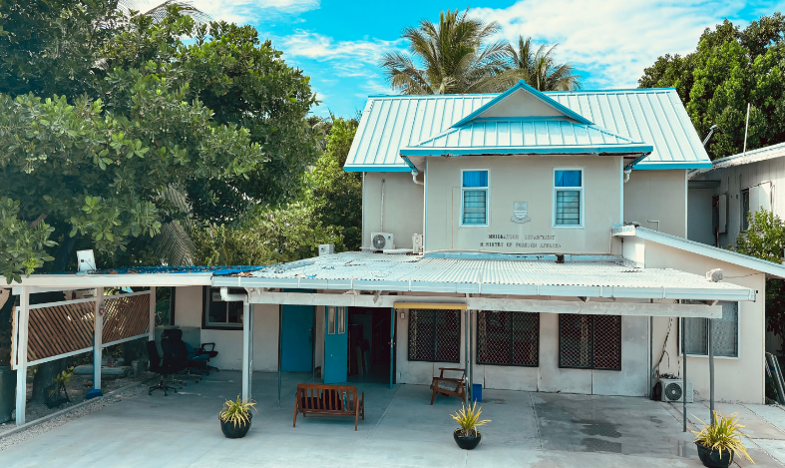
About Us
Role and Function

The Passport Section, under the Immigration Division of the Ministry of Foreign Affairs and Immigration, is responsible for the issuance and management of Kiribati passports and other travel documents.
Whether it is a first-time passport application or a renewal, our team is committed to delivering services with professionalism, accuracy, and integrity. We also provide guidance on passport requirements, assist with replacement of lost or damaged passports, and ensure that all travel documents are issued in accordance with national laws and regulations.

📞 Phone: +686 75021342 ext 227
📧 Passport Enquiries: passportofficer1@mfa.gov.ki
passportofficer2@mfa.gov.ki
🌐 Website: http://www.mfa.gov.ki
📍 Address: Bairiki, Tarawa, Kiribati

Contact Us

Immigration Division
PASSPORT SERVICES


Thank You

Scan to read more

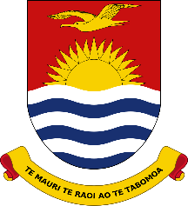

Ministry of Foreign Affairs & Immigration

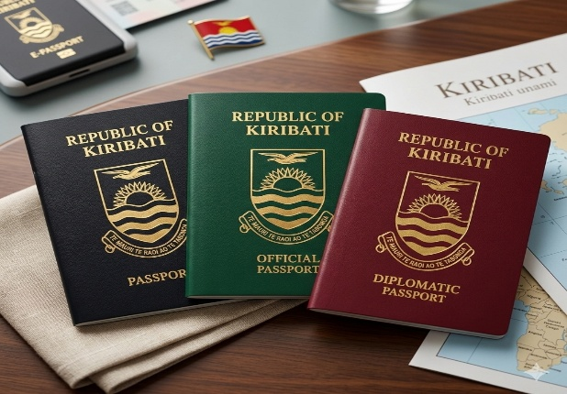
i
Lost or stolen passport? Here’s what to do:
- Report lost or stolen passports immediately to the Passport Office
- Notify the Police and obtain a police report
- Apply for a replacement
For lost, stolen and damaged passports, penalties apply as follows:
1st time: $100
2nd time: $300
Applicants who have lost or had three (3) or more passports reported lost or stolen within a five-year period may not be issued another passport.

Insert tittle

As a Passport holder, you have the responsibility to:
🛂 Keep your passport safe – Protect it from loss, theft, or damage.
✅ Use it lawfully – Only for legal travel and identification purposes.
📝 Provide accurate information – Ensure all personal details on your passport are correct.
🔄 Renew on time – Keep your passport valid; don’t let it expire before your travel.
🚫 Report loss or theft immediately – Notify the Passport Office if your passport is lost or stolen.
🌐 Comply with international laws – Follow visa requirements, entry/exit rules, and local laws while abroad.

Your PASSPORT is not just a travel document, it’s a legal responsibility and proof of your identity and nationality.

KIRIBATI PASSPORT
🧑‍💼 Who Can Apply:
All citizens of Kiribati – first-time applicants or renewals
👶 Minors (under 18years of age): Require parental or guardian consent
📄 Proof Required: Identity (birth certificate and national ID and citizenship certificate only if required)

Confirmation of identity of an applicant is a requirement under Regulation 5 of the Passport Regulations 2014.
Who is authorized to confirm the identities of applicants?
Secretaries (of Government Ministries)
Member of Parliament
Mayor of a Local Council
Priest / Catechist / Pastor / Minister of Religion
Police Officer
Lawyer
Doctor
Magistrate
Passport fees and processing time:
- Priority/ Urgent (1 day) - $112.50
- Expedited (3 days) - $98.40
- Standard (5 days) - $84.40
- Normal/ regular (10 days) - $56.25

What is a Certificate of Identity (COI)?
A COI is a travel document issued to individuals who do not have a valid national passport but need a travel document for identification and travel purposes. It serves as an alternative travel document and may be issued under special circumstances.
The Kiribati COI can only be used within the region. Travel beyond the region requires a valid passport.

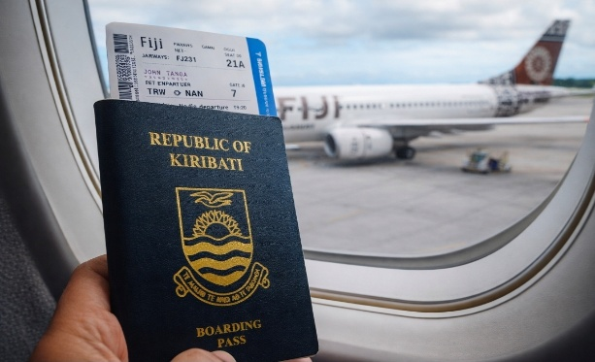
(Right click on the image and select change picture)

Insert tittle

