
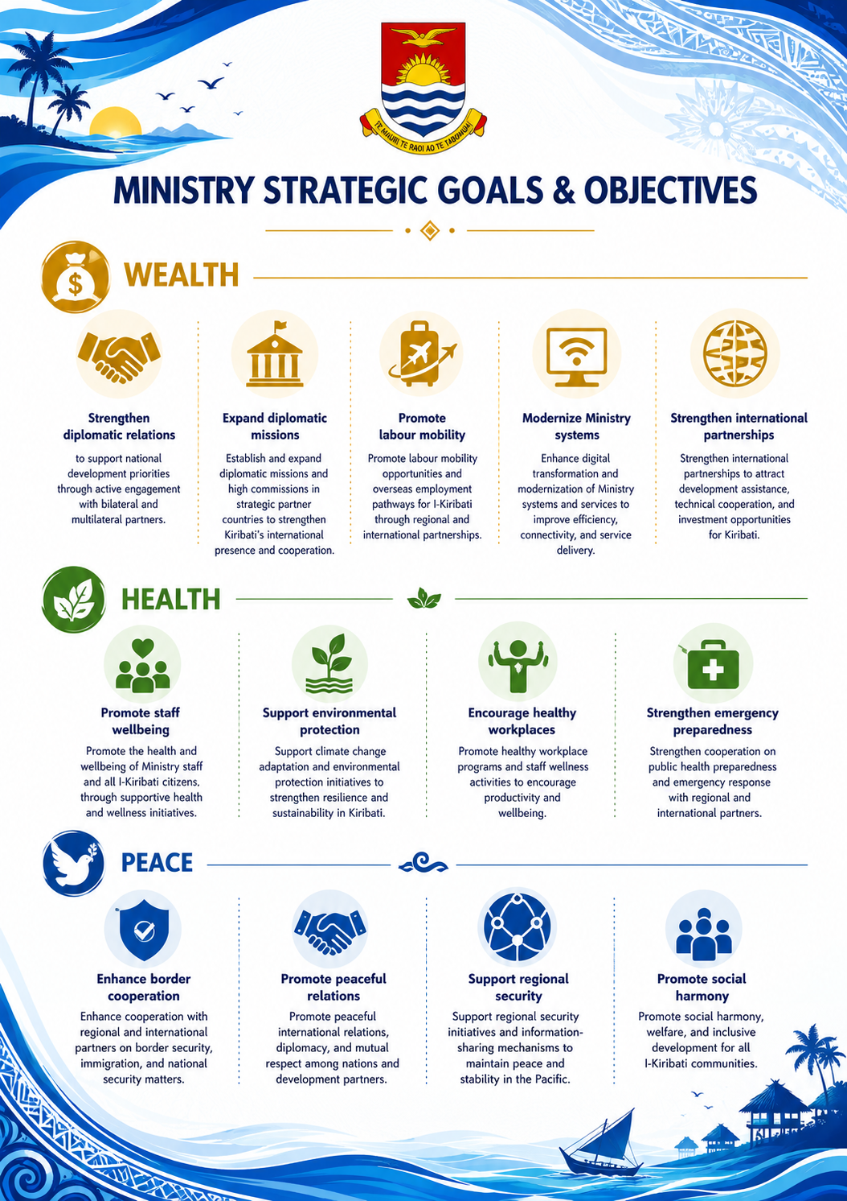
MINISTRY STRATEGIC GOALS & OBJECTIVES

Social harmony
Promote social harmony, welfare, and inclusive development for all I-Kiribati.
Regional security
Support regional security initiatives and information-sharing mechanisms.
Peaceful relations
Promote peaceful international relations and mutual respect among nations.
Border cooperation
Enhance cooperation with regional and international partners on border security matters.
Emergency preparedness
Strengthen cooperation on public health preparedness and emergency response.
Healthy workplaces
Promote healthy workplace programs and staff wellness activities.
Environmental protection
Support climate change adaptation and environmental protection initiatives.
Promote staff wellbeing
Promote the health and wellbeing of Ministry staff and all I-Kiribati citizens.
Strengthen partnerships
Strengthen international partnerships to attract development assistance and investment.
Modernize Ministry systems
Enhance digital transformation and modernization of Ministry systems and services.
Promote labour mobility
Promote labour mobility opportunities and overseas employment pathways for I-Kiribati.
Expand diplomatic missions
Establish and expand diplomatic missions and high commissions in strategic partner countries.
Strengthen diplomatic relations
Strengthen diplomatic relations to support national development priorities through active engagement with bilateral and multilateral partners.

